**DAILY ONLINE ACTIVITIES SUMMARY**

|  |  |  |  |  |  |  |  |
| --- | --- | --- | --- | --- | --- | --- | --- |
| **Date:** | **3/06/2020** | | | | **Name:** | **Imran Khan** | |
| **Sem & Sec** | **8th A** | | | | **USN:** | **4AL16CS040** | |
| **Online Test Summary** | | | | | | | |
| **Subject** | | **--** | | | | | |
| **Max. Marks** | | **--** | | **Score** | | **--** | |
| **Certification Course Summary** | | | | | | | |
| **Course** | **Python for Data Analytics** | | | | | | |
| **Certificate Provider** | | | **IBM** | **Duration** | | | **2.5 HOURS** |
| **Coding Challenges** | | | | | | | |
| Problem Statement:  Write a C Program to subarray.. | | | | | | | |
| **Status: Solved** | | | | | | | |
| **Uploaded the report in Github** | | | | **yes** | | | |
| **If yes Repository name** | | | | **Imran040** | | | |
| **Uploaded the report in slack** | | | | **yes** | | | |

**Certification Course Details**:

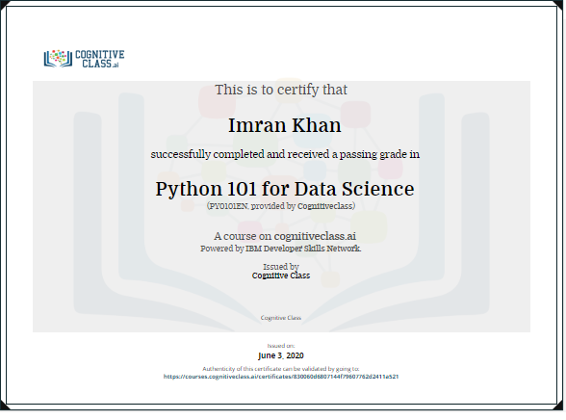

**Coding Challenges Details**:

**program1:**

|  |
| --- |
|  |
| #include<stdio.h> | |
|  | |  |
|  | | void main() |
|  | | { |
|  | | int a[] = {1, 2, 1, 5, 2}; |
|  | | int n = sizeof(a) / sizeof(int); |
|  | | int result = 0, val, i ,j; |
|  | |  |
|  | | for(i=0; i<n; i++) |
|  | | { |
|  | | result ++; |
|  | | val = a[i]; |
|  | |  |
|  | | for(j=i+1; j<n; j++) |
|  | | { |
|  | | if(a[j] == val) |
|  | | result++; |
|  | | } |
|  | | } |
|  | | printf("%d",result); |
|  | | } |